**Osticket System SLA Plan** -   
  
**Add New plan for demo**  
  
Go to **Admin >> Manage >> SLA >>**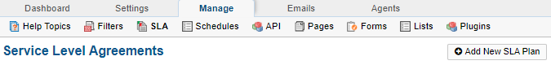  
Click on **Add New SLA Plan** under in admin section and configure the custom sla (**High SLA**) , for ex- we created **High SLA**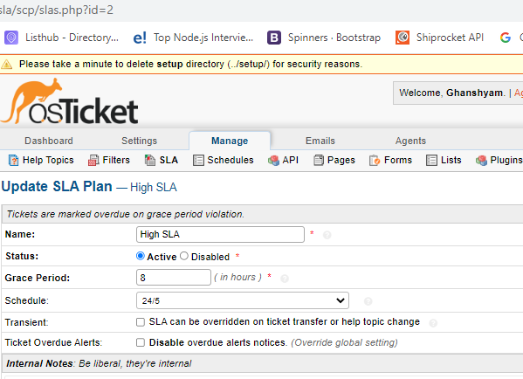

**Same as you can create many SLA Plans as per your need . You can add more SLA Plan later also or at any point of time , But to support the SLA Addon plugin you need to create instance seperatly for each plan .**